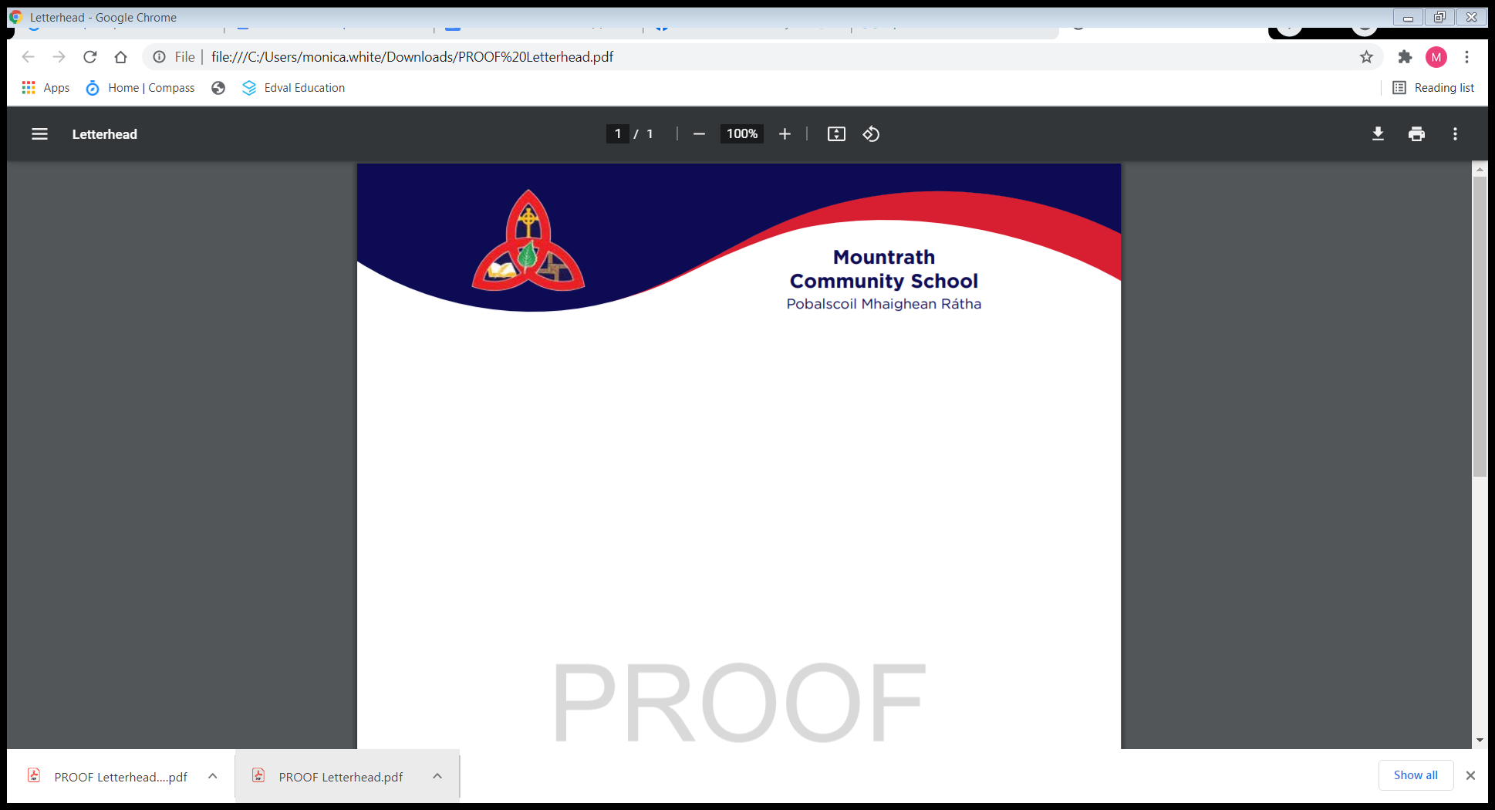Post of Responsibility - Appeals Form

***Post of Responsibility Appeals Process and Form***.  
  
**The Appeal Procedure**  
Appeals in respect of competitions for posts of Assistant Principals I, Assistant Principal II and Programme Co-ordinator posts shall be completed **electronically**on the agreed PDF Appeal Form.  Only appeals completed and submitted using the electronic form will be processed.  Appeals submitted after the *Appeal Date* will not be processed.  
   
The Appeal Procedure is not a re-examination of the interview itself.  
​​**Scope:**   
The Appeal Procedure is used in respect of appeals to the following posts: Assistant Principal I, Assistant Principal II, Programme Co-ordinator posts (at AP I and AP II level) and Assistant Director of Adult Education (at AP I and AP II).  
It does not apply to Principal and Deputy Principal Posts or the post of Director of Adult Education at Deputy Principal Level.  
​  
**Appeal Date:**   
This is 4.00 p.m. on the **seventh school day**, with day one commencing on the day after the outcome of the process is issued.   
  
**Grounds for appeal and responding to appeal grounds**  
   
The grounds for appeal may be on one or more of the following in relation to an alleged breach of procedure:  
   
(A) Pre-interview:

1. Failure to consult staff on the roles and responsibilities as set out in circular letter 0003/2018.
2. Breach of advertising rules.
3. Non-notification about the vacancy to teachers on leave of absence/secondment.

(B) Composition of the Interview Board:

1. Lack of gender mix on Interview Board.
2. Incorrect/incomplete composition of the Interview Board.

(C) Marking/Selection Criteria:

1. A computational error in the Interview Board Marking Sheet which makes a material difference to the outcome.
2. A departure from the agreed selection criteria or Marking Scheme.

Appeal grounds must be substantiated (i.e. supporting evidence must be supplied).  
   
Appellants are required to substantiate **each** appeal ground selected on the **electronic appeal form**with a supporting rationale/defence. The supporting rationale must be relevant to the specific appeal ground selected.  
   
Where nothing is provided by way of a rationale/defence of the appeal ground selected, the appeal ground will be discounted by the Appeal Board and reference to this effect will be included in the Appeal Board determination.  
   
Only documents specifically referenced in the statement of appeal or management response to the appeal are admissible. Any additional and/or unsolicited documentation will not be considered by the Appeal Board and will be returned to the sender. The Appeal Board may seek copies of certain documents relevant to its consideration of the appeal from either party to appeal.  
   
Upon receipt of documentation from the Appeal Board Secretariat, the Appeal Board undertakes a preliminary review of each appeal submitted, the corresponding management response submitted, supporting documentation, relevant Department of Education & Skills circulars/forms appropriate to such competitions.   
   
The Appeal Board will examine each appeal ground selected and supporting rationale/defence.  The Appeal Board will examine the management response to the appeal ground selected and management’s rationale/defence. Each appeal ground will be considered and adjudicated upon.  
                                    
Appeals shall not include observations or disparaging remarks of a personal nature including personalised comments about individuals. Where this transpires, it may lead to an appeal being disqualified by the appeal board or an oral hearing being terminated by the Appeal Board.  
   
Where the Appeal Board, having considered the appeal and response, deems it **unnecessary** to conduct a hearing, it shall notify the appellant and the Secretary of the Board of Management of the outcome of the appeal within **fifteen school days** of the *Appeal Date*.  
   
Where the Appeal Board, having considered the appeal and management response, decides that a hearing is **necessary**, it shall set a date for a hearing within **fifteen school days** of the *Appeal Date*.    
   
Where additional documentation is sought prior to an appeal hearing by the Appeal Board, the parties should co-operate in furnishing same as soon as possible to the Appeal Board to facilitate the exchange of such documentation to the other party not later than three school days prior to the hearing. No documentation shall be admissible at the hearing which has not been supplied in accordance with the timeline.  
   
The Appeal Board may draw any inference/conclusion it desires in respect of the failure of either party to provide documentation requested by the Appeal Board.  
  
​  
**How the appeal process operates**

* A candidate who wishes to appeal must complete the **agreed PDF Appeal Form electronically.** Only appeals completed and submitted using the electronic form will be processed.
* Appeals submitted after the *Appeal Date* will not be processed.
* Both appeals and response to appeals are each limited to a total submission of **1,000** words.
* Documentation (if any) which is relied on to support an appeal and referenced in the appeal form must be submitted **by email or in hard copy** to the Secretary of the Board of Management by 4p.m. on the *Appeal Date.*Any documentation received after this time will not be processed and will be returned to the appellant.
* If no appeal is received within this timeframe, the Board of Management will proceed with the appointment of the recommended candidate.

**Where an appeal/s is/are submitted:**

* *To the recommended candidate:*  The recommended candidate for the post is advised (on receipt of an appeal/s) that an appeal/s has been lodged and that the appointment to the post is postponed pending the outcome of the appeal/s lodged and s/he will be notified of the outcome in due course.  This letter can issue directly on receipt of an appeal.
* The Secretary of the Board of Management emails the Appeal Board Secretariat advising of the *Appeal Date*.
* If there is an appeal/s made, the Secretary to the Board of Management sends a letter to the appellant acknowledging receipt of the appeal. This letter should issue within 3 school days of the Appeal Date
  + Secretary to the BOM will complete the Management Response to Appeal Form.
  + The Secretary to the BOM returns the completed PDF Management Response Form and supporting documentation, including documentation received in hard copy from the Appellant(s) – either scanned as PDF or in hard-copy, marked ‘Private and Confidential’ within **five school days** of the *Appeal Date* and will simultaneously send a copy of the management response to the appellant.
* The Secretary to the Board of Management and the appellant will be notified by the Appeal Board Secretariat as to the composition of the Appeal Board within seven school days of the Appeal Date.